Design Alternatives
AI document: https://chatgpt.com/share/69812c72-8da8-8009-8bf9-6b5574d73803

Single App, Separate “Shells” (Role-based Layout Packages)
Concept: One codebase + one domain, but two top-level UI shells (PatientShell, DoctorShell). After login, the router mounts exactly one shell and the other isn’t even loaded.
Why it’s better:
- Stronger separation than “dynamic dashboard” (no accidental cross-rendering).
- Less maintenance than “split portal” (shared build, shared components, shared design system).
- Cleaner navigation: each shell owns its own menu/IA.
Implementation hint: role-gated routing + code-splitting: /app/* → mounts DoctorShell or PatientShell based on permission.

Components:
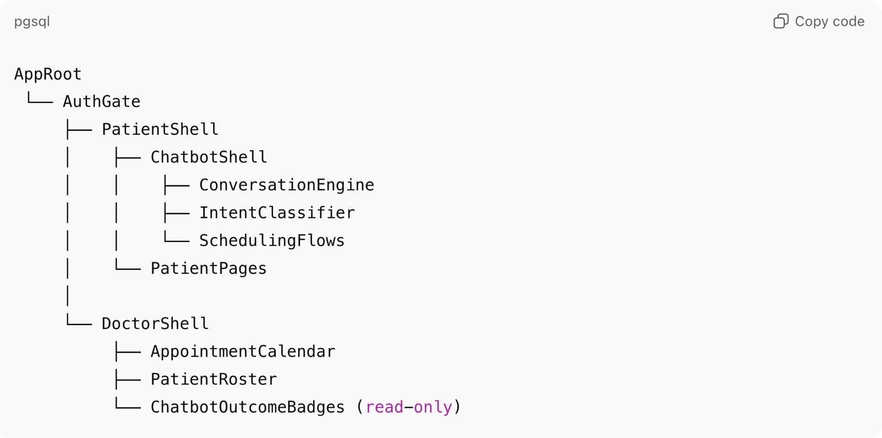

1) Shared components (used by both shells)
Routing & security
- AuthGate (login/session)
- RoleRouter (mounts either PatientShell or DoctorShell; never both)
- RouteGuards / AccessControl (blocks cross-role routes)
Account management
- DemographicsProfileEditor (first name, last name, email, address, phone no)
- AuditLogService (records demographic changes)
Appointments (shared domain layer)
- AppointmentAPI / AppointmentService
- ConflictDetector (prevents double-booking)
- Notification/Toast (used for booking confirmation UI)
UI foundation
- AppLayout primitives (page container, cards, tables)
- Common components (Button, Modal, FormField, Loading states, Empty states)

2) PatientShell components
Onboarding
- PatientOnboardingForm
- DoctorLinkStatus (patient linked to doctor only after confirmed appointment)
Symptoms
- SymptomLogForm (symptom + timestamp)
- SymptomTimeline / History
- SymptomAutoShareService (auto-sends symptoms to primary care / upcoming appointment doctors)

Appointments
- AppointmentHistoryPage (scheduled + past list)
Summaries
- ApprovedSummaryList + SummaryViewer
- SummaryLabelBanner (“AI-generated summary”)
- ClarificationOrInaccuracyForm
- SummaryLock (patient cannot edit/regenerate summaries)
Medication
- MedicationListViewer (patient reviews prescribed meds)
Health metrics
- HealthMetricsEntryForm (weight/height/water intake)
- HealthMetricsCharts (graphs/trends)
- HealthMetricUpdateGuard (updates only their own data)

3) DoctorShell components
Onboarding
- DoctorOnboardingForm (office location, area-of-focus, office hours)
- AvailabilityManager (define/update available slots)
Patient access control
- PatientRoster (filtered) (only patients who shared data or had appointment)
- PatientDetailView (reachable only from roster)
Appointments
- DoctorCalendar / ConfirmedAppointmentsView
- DoctorCancelAppointmentAction
Note synthesis (AI summaries)
- VisitNotesInput / NotesUploader
- AISummaryGenerator
- SummaryEditor + ApproveSummaryAction
- SummaryMetadataPanel (time, approving doctor, related visit)
- SafetyGuardrail (no diagnosis/treatment unless authored by doctor)
- Patient-Visit Binding Validator (summary only from same patient’s visit notes)
Medication
- MedicationReconciliationEditor (doctor ensures med list accuracy)
Health metrics
- PatientMetricsDashboard (doctor views patient graphs)

4) Chatbot components (PatientShell-enabled)
Shared chatbot infrastructure
- ChatbotShell (open/minimize panel)
- ConversationEngine (state manager)
- MessageRenderer (bubbles + action cards)
Patient appointment flows (requirements)
- IntentRouter (schedule/view/cancel)
- DoctorListCard (shows multiple doctors)
- TimeSlotPickerCard (shows/query available slots)
- BookAppointmentAction + ConfirmationCard (immediate on-screen confirmation)
- RetrieveAppointmentCard (current appointment details)
- CancelAppointmentFlow (cancel via chatbot)

